24th International Seminar
„Track Maintenance Machines in Theory and Practice - SETRAS 2024“
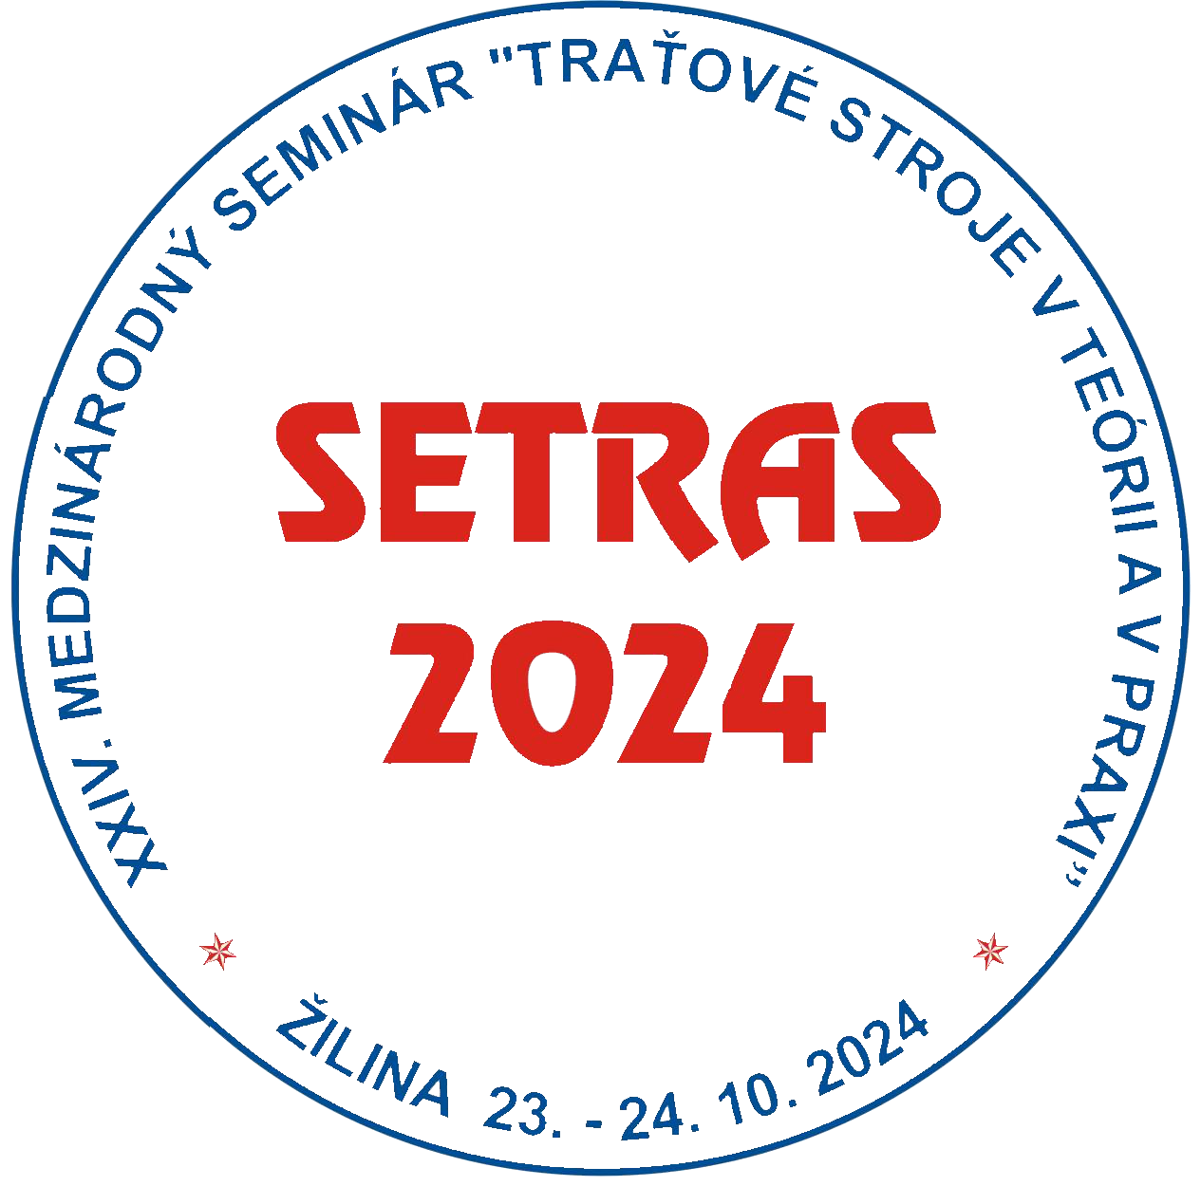

October 23 - 24, 2024
Hostels of the University of Zilina, Block G-H (GAMA Club), ZILINA, SLOVAKIA

under auspices of

Rector of the University of Zilina
prof. Ing. Ján ČELKO, CSc.
.
and
Director General of Railways of the Slovak Republic (ZSR)
JUDr. Alexander SAKO

Organizer:
Scientific and Technical Society at the University of Zilina
in co-operation with
General directorate of ZSR

PROGRAMME AND ORGANIZING COMMITTEE OF THE SEMINAR
Ing. Peter BADO, GJW Praha, Ltd., Czech Republic
doc. Ing. Dalibor BARTA, PhD., Faculty of Mechanical Engineering, University of Zilina, Slovakia
doc. Ing. Peter BLAHO, PhD., MBA, General directorate of ZSR, Bratislava, Slovakia
Ing. Tomáš DŽUGAN, Rail Servis Slovakia, Ltd. Martin, Slovakia
Ing. Pavel FIALA, Ph.D., Správa železnic, s. o., Technology and diagnostic center, Praha, Czech Republic
prof. Dr. Ing. Juraj GERLICI, Faculty of Mechanical Engineering, University of Zilina, Slovakia
Mgr. Jaroslav HANKO, ŽSR Regional Direktorate Žilina, Slovakia
Ing. Jozef KOVAĽ, ŽSR - Railway Institute for Research and Development, Zilina, Slovakia
Ing. Mojmír NEJEZCHLEB, Správa železnic, s. o., Praha, Czech Republic
doc. Ing. Janka ŠESTÁKOVÁ, PhD., General Directorate of ŽSR, Bratislava, Slovakia.

Chairman of the Committee
prof. Ing. Daniel KALINCAK, PhD., Department of Transport and Handling Machines, Faculty of Mechanical Engineering, University of Zilina, Univerzitna 1, 010 26 ZILINA, SLOVAKIA., mobil: (+421) 907 586 005
e-mail: daniel.kalincak@fstroj.uniza.sk.

Committee secretary:
doc. Ing. Dalibor BARTA, PhD., Department of Transport and Handling Machines, Faculty of Mechanical Engineering, University of Zilina, Univerzitna 1, 010 26 ZILINA, SLOVAKIA Tel.: (+421 41) 513 2654, mobil: (+ 421) 918 663 371,
e-mail: dalibor.barta@fstroj.uniza.sk.

Seminar languages:
Slovak, Czech, English.

Seminar objectives:
The International Seminar SETRAS 2024 is organized for railway workers, urban transport and factory transport workers, manufacturers and users of track maintenance machines and its components, research and development workers, designers, universities staff and people interested in research, development, design, testing, technology, operation and maintenance of track maintenance machines.
The aim of the Seminar is to bring information to participants about state and perspectives of development in the field of track maintenance machines, small and heavy machinery for track construction and maintenance, track measurement devices and cars etc.
This year the preferred topics of the Seminar are machinery for modernisation of railway track, rail/road vehicles, equipment for measurement, monitoring and diagnostics of railway track (track recording cars, rail profile measuring equipment, rail flaw detection systems, measuring of rail support stiffness etc.), small machinery for rail and switches maintenance, utilization of new building machines in modernisation of railway track, tunnels, bridges, maintenance and refurbishment of track maintenance machines, testing of track maintenance machines.
Further aim of the Seminar SETRAS 2024 is to offer to the companies possibility of presentation its products and services.

Information about the possibilities of promoting companies on SETRAS is in the file ELADV24.docx.

Information about place of the Seminar you can find at information map and information about urban transport at http://www.dpmz.sk/.
Further information about the Seminar will be continuously updated.

